**Most people have forgotten the meaning behind traditional or**

**religious festivals; during festival periods, people nowadays only**

**want to enjoy themselves. To what extent do you agree or disagree**

**with this opinion?**

Some people argue that we no longer remember the original meaning of

festivals, and that most of us treat them as opportunities to have fun.

While I agree that enjoyment seems to be the priority during festival

times, I do not agree that people have forgotten what these festivals

mean.

On the one hand, religious and traditional festivals have certainly become

times for celebration. In the UK, Christmas is a good example of a festival

period when people are most concerned with shopping, giving and

receiving presents, decorating their homes and enjoying traditional meals

with their families. Most people look forward to Christmas as a holiday

period, rather than a time to practise religion. Similar behaviour can be

seen during non-religious festivals, such as Bonfire Night. People

associate this occasion with making fires, watching firework displays, and

perhaps going to large events in local parks; in other words, enjoyment

is people’s primary goal.

However, I disagree with the idea that the underlying meaning of such

festivals has been forgotten. In UK primary schools, children learn in

detail about the religious reasons for celebrating Christmas, Easter and

a variety of festivals in other religions. For example, in late December,

children sing Christmas songs which have a religious content, and they

may even perform nativity plays telling the story of Jesus’ birth. Families

also play a role in passing knowledge of religious festivals’ deeper

significance on to the next generation. The same is true for festivals that

have a historical background, such as Bonfire Night or Halloween, in the

sense that people generally learn the stories behind these occasions at

an early age.

In conclusion, although people mainly want to enjoy themselves during

festivals, I believe that they are still aware of the reasons for these

celebrations.

(296 words, band 9)

***The maps below show changes in the city of Nelson in recent times.***

***Summarise the information by selecting and reporting the main features, and make comparisons where relevant.***

Write at least 150 words.

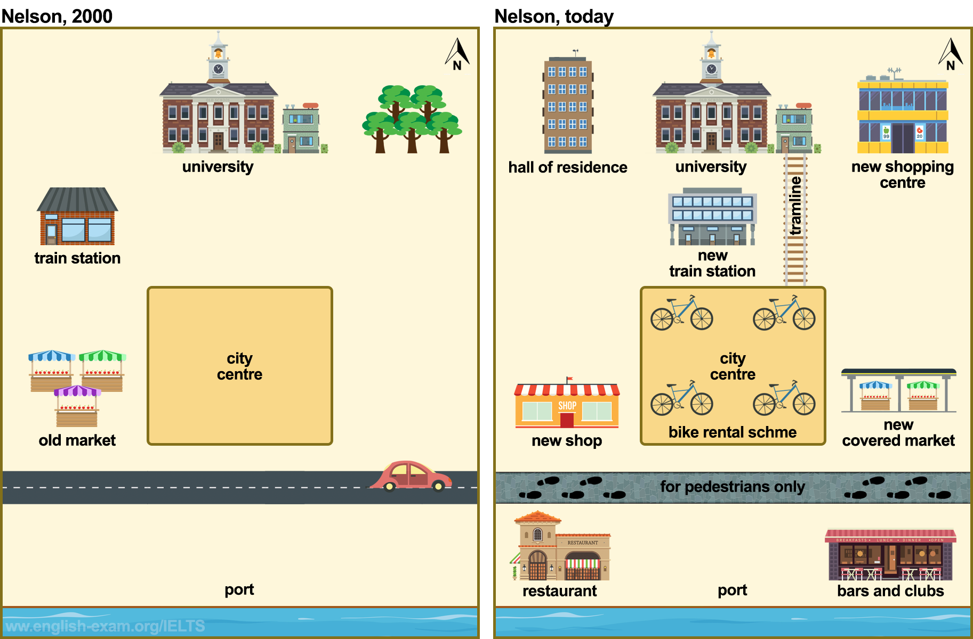

### *The two maps illustrate the development of Nelson city*

### **Model answer**

The two maps show the main changes which have taken place in the town of Nelson between the year 2000 and today.

In general, it appears that Nelson has become a much more modern city, with far more shopping and transport facilities.

One interesting change is that a new trans line has been built, to connect the university with the town centre. In 2000, there wasn't any accommodation for students, but a hall of residence has been built near the university. Another striking change is that the old market in the west of the city has been knocked down to make way for new shops. A completely new covered market has also been built on the other side of town.

If we look at the port area, it has been pedestrianized since 2000, and a range of entertainment facilities have been built, such as restaurants, bars and clubs. The north-east of the city used to be a green area, with lots of trees, but the trees have been cut down, and a new shopping complex has been constructed. A final interesting development has been the introduction of a bike-rental scheme in the city centre.

(194 words)